INTEGRATED FACE DETECTION AND TIME-STAMPED ATTENDANCE MONITORING

Ganesh G1, Manoj Kumar K2, Shameer S3, Sai Ramana N4, Yashoda Krishna K5

1 Assistant Professor, Dept. of CSE, Srinivasa Ramanujan Institute of Technology, Anantapur, India.

2,3,4,5 Dept. of CSE, Srinivasa Ramanujan Institute of Technology, Anantapur, India.

Email: [ganeshg.cse@srit.ac.in1,](mailto:ganeshg.cse@srit.ac.in1) [224g5a3308@srit.ac.in2](mailto:224g5a3308@srit.ac.in2)

**Abstract**

Using technology for attendance systems is usually time-consuming and error-prone. Managing students and entering data of bulk students can be a time-consuming process and prone to data entry errors. In this purpose, we have designed a System to integrate face Detection and time-stamped based system which makes use of face detection and face recognition techniques to avoid the manual way of data entry. For face detection, we use HOG + SVM or CNN based and for face recognition, we use Deep Metric Learning (ResNet-34). It performs a face matching using Euclidean distance based face matching to the match detected faces to a database of stored faces thus producing a very good accuracy of face identification. This model is implemented in python using openCV and face_recognition libraries. In addition, it implements an auto attendance mechanism by using OpenPyXL library to input real time data into a Excel sheet. GUI based on Tkinter is included to improve the usability, monitor attendance in real time and track attendance. This flawless and secure identification makes the system a good recommendation for schools, organizations, and access control. This solution replaces manual entry of attendance therefore making attendance more efficient and minimizing errors while providing a practical output and automatic way of addressing attendance issues for different scenarios.

**Keywords**: HOG, SVM, CNN, ResNet-34, Euclidean Distance, KNN, OpenPYXZ.

# Introduction

Face recognition has rapidly evolved as an essential technology in many fields, such as security, authentication, and attendance management. Unlike traditional methods, face recognition provides a fast, accurate, and non-intrusive way to identify individuals. This is most effective for attendance system automation where manual processes have their limitations. By the traditional/Existing type of taking attendance, there is much greater scope of errors and fraud like proxy attendance, etc., which can be altogether eliminated through a face recognition based attendance system, thereby improving overall efficiency.

The process of the system is in stages and begins with face detection, which finds the face on the image or video Stream. After Detection stage there is a feature extraction stage where important characteristics of a human face like Eyes, Nose, Jawline types are extracted. And it encodes these features into a mathematical format called face encoding. This way of face recognition is the last step, in which system will match the previously recorded encoded face. with a database who the person you’re looking for is. They combine which to make automate the attendance system process by recognizing people in real-time and updating their attendance records in an Excel sheet.

Integrated Attendance monitoring system based on facial detection and recognition as proposed Attendance marking is done automatically by detecting and recognizing People real time, record change in excel sheet for easy tracking. It provides prosperity like this, so jobs, services, gatherings and it has many places. less manual effort higher speed for registering of attendance improved security and no proxy attendance.

It also provides a contactless mode of attendance, useful during these times, plus it minimizes the safety as well as the accuracy.

This is a setup that works on any context and scenario. Despite these many benefits of this tool, it still has some limitations such as proper lighting, face expressions and obstructions which deteriorate the performance of face escape by accuracy rate. These challenges can be closed using definite techniques like data augmentation, image enhancement, and liveness detection. These techniques ensure more. Good performance and versatile applications.

The face recognition system involves multiple tasks; [1] detection of a particular face in an image, [2] identification of an individual face even under the conditions of varying illuminations, angle or expression of the face and [3]. different types of depth of the eye, shape of the nose and other dimensions of face. Humans are born with the ability to identify faces but machines have to be trained specifically to recognize faces with respect to these salient attributes. Finally the student/students data is feed in Excel Sheet[4].

There are two main categories of facial recognition. Processes:

1. Verification
2. Identification

Verification (One-to-One Matching) is an exercise of finding whether a known user face matching (usually for) identity systems for unlocking devices and authentication.

Identification (One to Many Matching): Identifies the an one out of the group, which is necessary for things like Attendance automation and security monitoring.

# Literature Review

## “Automated Attendance System Using Face Recognition.”

The first research paper, which is written by Akshara Jadhav, Tushar Ladhe and Krishna Yeolekar(2017) is applied to face based attendance monitoring system to increase efficiency and security. Automatically identifies and marks attendance of students entering the classroom. PCA works well in real-time applications achieving an optimal recognition rate and a lower false-positive rate [2]. Even if someone has had their haircut, or has began growing a beard, in the future it could be trained to not only recognize voice, but faces as well. Moreover, the recognition process is improved through enhancing the robustness inside a variation of the angle of the face up to only 30-degree which requires also enhancement.

## “Face Recognition-Based Attendance Marking System”

The second study, “Face Recognition-Based Attendance Marking System” by Senthamil Selvi, Chitrakala, and Antony Jenitha (2014), proposes a solution to previous limitations in traditional attendance management methods. The system captures images of students or employees using a camera, processes the facial features, and compares them with a database for authentication. Attendance is recorded only when a match is found in the database, ensuring security and preventing fraudulent entries. One of the key advantages of this system is that the attendance data is securely stored on a server, reducing the chances of manipulation. Furthermore, the system enhances face detection accuracy by employing skin classification techniques. However, despite improvements in detection accuracy, the system is not portable, as it relies on a standalone computer with a continuous power supply. While this setup is feasible for staff attendance (as they report once daily), it poses inconvenience for students who need to register attendance for multiple sessions per day. A proposed solution is to develop a portable module capable of running the Python- based attendance program seamlessly.

## “Implementation of an Automated Attendance System Using Face Recognition”

The Third study, “Implementation of an Automated Attendance System Using Face Recognition” by Mathana Gopala Krishnan, Balaji, and Shyam Babu (2015), aims to minimize faculty workload while optimizing time management. The authors introduce an automated attendance system that benefits educational institutions by reducing manual efforts. Attendance is recorded within a predefined time frame, after which the system automatically closes the session. Recognized faces are gathered in database, and the system also generates the absent student list. The recognition Eigenfaces is based on the eigenface algorithm, This process is based on concept of eigenface algorithm, The eigenvalues of the sample eigenface-based e eigenvectors. Face recognition using eigenfaces to recognize and classify faces. The system starts with a collection of training images and goes on to compare against the stored template eigenvectors of incoming faces to verify identity. learned to recognize unidentified faces if they appear multiple times recognize it over time.

# System Design and Architecture

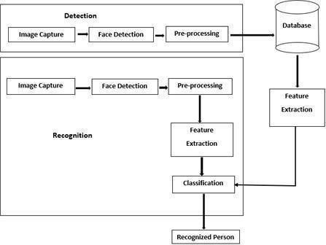

Figure 1: Proposed Work Architecture

Our Project suggest that to use Integrated face detection technique that monitors the attendance and tracks the attendance, High resolute cameras are used to capture image or from video images are captures, and the faces are saved in database for face detection and recognition, once the camera capture the user face it compare into the database, only if the face matches, attendance of the user marked into the Excel Sheet, and Attendance is tracked.

The system is a typically separated into two major parts: Detection and Recognition. Detection Phase: In this step the system first captures an image using a camera and then apply face detection algorithms to find the face and crop it out. After the face is detected, the face is pre-processed by removing noise, normalization, and alignment. These features are then stored in a database for further comparisons. A model called SVM and deep learning models like ResNet-34 is used to compare with extracted stored features. On finding a match, the system identifies the person; otherwise, it may categorized as an unknown.

Integrated Face Detection attendance system starts with an- image acquisition module based on a camera to get their real- time video or images after they enter a room. Face recognition takes images from this and processes module that detects the faces in every frame and gives their coordinates. Once a When a specific box for the area where a face is detected, a feature extraction process is used by the system that digital footprint based on critical features of the face encoding to a human face representation (or Face encodings).

These encodings are then checked against a database of known. Now they can simply use faces to identify people. When a matched features found, the Screening System automatically records attendance. The name of the person, the date, and the time into a secured database or table. The system architecture is modular and scalable; it enables convenient analytics and integration with other platforms. A user- Inexpensive operating system built in some tools like Tkinter. frameworks allows administration and user management between track registrations and attendance in one-click.

# Methodology

## Data Acquisition:

The process of the Integrated face detection attendance monitoring system consists of several steps that follow in a sequence, and data acquisition is the first step, which is generic for any model design as the influence of data on model performance is huge. It starts with images and live video frame captured by a webcam or some embedded camera. Hence the robustness of the model heavily depends on the quality and diversity of the collected dataset and we need to collect the images in different scenarios.

A data set is compiled from many images of the same individual showing different angles, like lighting conditions and expressions. OpenAI explains that a diverse dataset helps the model generalize and perform well during real-case scenarios. This needs to include frontal, slight side profile images and images in bright and low lighting setting. To guarantee that even the individuals are not the best conditions, the model recognizes it. In controlled circumstances, the information acquisition is generally more precise as a result of controlled environment scan reduce mistakes. Fix the background, fix the lighting, and fix the camera position to ensure consistency of the images.

## Pre-Processing:

The second step in face recognition is pre-processing which is necessary in that it prepares the images in a suitable way by improving image quality, reducing noise and making sure that the dataset is consistence. The initial step of pre- processing is to turn the images captured to grayscale. By removing color it reduces the computation complexity loss of information which preserves important facial traits. Since most Shape, texture, and Image-based face recognition algorithm mostly rely on shape and Texture, Grayscale images give you edge details rather than color where in sufficient information is retained to meet the goal, while processing efficiency is optimized.

Next, all the images are put to a fixed size, which is mostly Either 64 x 128 pixels or 128 x 128 pixels. Standardizing image Dimensions harmonizes disparate input dimensions across the dataset, enabling the model to channel its processing power more efficiently. This step avoids some other problems, like different dimensions of images, ratio of image, etc.

## Face Detection Using HOG and SVM:

A face detection module accepts pre-processed images which detects and localizes faces in each frame. Utilizing the traditional approaches got more popularity compare to the ran the modern deep learning detectors or classical methods, the Takes as Input Frames and System draws bounding boxes on detected faces./

This step has a feature where it isolates facial regions to reduce the noise of backgrounds and zoom in on some fine- grained scope of inquiry. Face detection is an important part of various applications are integrated putting systems on track to detect and recognize human faces.

Main two techniques for face detection The Histogram of Oriented Gradients (HOG) for feature extraction, detection using Support Vector Machine (SVM) , and Convolutional neural networks (CNN) recognize the faces, The HOG descriptor takes the overall shape of an object based on the distribution of local intensity gradients get the edge directions and gradients by Edge Detection. When combined with linear SVM, proved to be very effective discriminates between faces and non-faces.

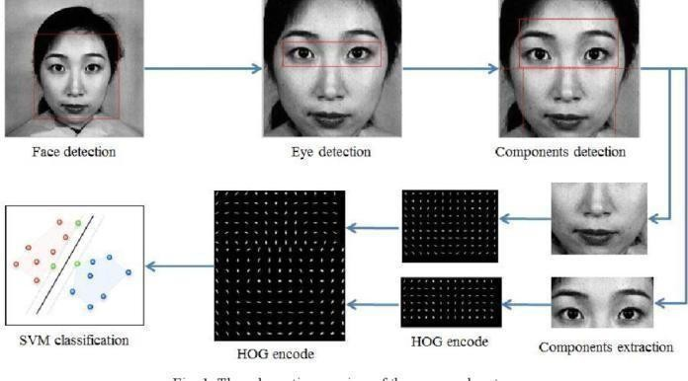

Figure 2: Human Facial Detection using HOG encoding and SVM Classification

Implementation Steps:

1. Preprocessing: This is the initial step of facial recognition where the input image is converted into grayscale. This transformation reduces computer errors and retains physical attributes of the individual. Also, it is resized to a fixed size (usually 64x128) to make sure all inputs are the same size. When there is standardization, different pictures are produced in similar format which makes it easy.
2. Gradient Computation: After going through the preprocessing step, the gradients along the x and y axes of the image are computed. There gradients show the change of pixel intensity through out the image to detect important facial features edges, contours, and textures. This is extremely beneficial to try to makes these structures more recognizable.
3. Orientation Binning: the subsequent work is to divide the image into tiny cells, typically with an 8x8 pixel. In every cell, a histogram of gradient directions is computed. This is the histogram of different orientations of edges and textures. These gradients tell them the attributed which differentiates this person from others. Present the formulation of step.
4. Block Normalization: In order to have invariance to the variation of light direction, 2×2 neighboring cells grouped into larger blocks. These blocks are more histograms and are normalized against changes of brightness and contrast. With this, we can also avoid the sensor making too sensitive system to external light conditions.
5. Feature Vector Formation: After the Histograms are normalized, they are concatenated to get a single feature vector. Here this vector is essentially a representation of your face which helps to distinguish features such as the structure of your face, how you place your edges and so on. This is a unique database identifier that is assigned to each person.
6. Classification: Finally a linear SVM classifier is trained upon the feature vector for the detection of the face or non- face So, the classifier is trained using a very large dataset of facial and non-facial images, so that it can be classified accurately.

The final step is to verify that the image contains a face so recognition can occur. The identified face areas are then aligned and processed for identification of unique facial characteristics. The model called FaceNet represents each face with a 128-dimensional feature vector. This encoding is a unique representation of a person s facial features so similar encoding can be used to identify a person even in different expressions and poses and lighting conditions.

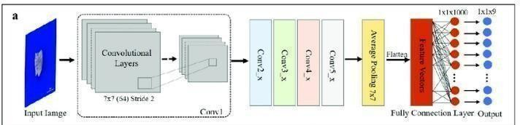

Figure 3: The overall structure of ResNet-34(mdpi.com)

ResNet-34: A workhorse solution for facial recognition along with a very strong capability to distill the salient features from human face images, here we implemented the 34-layer deep- residual-network, ResNet-34 to take advantage of its high performance. The design of it integrates residual learning in that it introduces shortcut connections embedding across one or more layers to avoid the headaches of training deep networks. With this mechanism it effectively prevents, vanishing gradient at play making sure everyone has their hand up when moving despite the network deepening. face recognition pipeline starts with obtaining a face image and performing preprocessing to ensure that the image undergo robotization of size, light and orientation. This standardized image taken as input to the ResNet-34 model. When the image passes through the layers of the network, different features of the face are gradually picked up and learned, starting from simple edges at the top of the network to complex textures and textures at the bottom of the network through a series of convolutions and pooling.

This can also be seen as we pass it through into Residual Blocks, which is a domain feature of ResNet-34. Inside each of these blocks, the input layer is added with its output, so that the residual functions with respect to the inputs of the layer can be learnt by the network. This not only enables training of deeper networks but also enhances feature extraction by maintaining the original input information and providing invariance at various layers.

## Face Matching :

On a match, the face encodings generated from a webcam image are checked against those stored directly or in a database using similarity metrics in most cases Euclidean distance. Thus, as the calculated distance is below or equal the threshold value the system identifies the face as that of similar one who is known, else it identifies the face as unknown such that the faces which are confirmed can only be registered.

Compute Euclidean Distance: Once we have two features

vectors, to compare two faces and see if they are the same, we simply use the Euclidean distance between the feature vectors. This distance measures the straight line distance between two points in the feature space by using the following formula:

(1)

Xi and Yi are the i-th components of the first and second feature vectors, respectively, and n is the dimension of these feature vectors. A small Euclidean distance implies that the two faces are similar, while a large distance means dissimilar faces. To decide if two faces aligned match, we can compare the resultant computed Euclidean distance to a threshold:

**Above Threshold**: The faces are matched, meaning they are probably from the same person.

**Over the Threshold**: Here, the images are declared as dissimilar. alluding to them being by distinct people.

## Attendance Logging:

The Integrated face detection system is performed and once a face is detected and recognized successfully attendance is taken automatically by capturing the ID or the name of the person along with the date and time. These are saved to a database or a use to a spreadsheet (csv file or Firebase) that you have access to in order to allow for efficient record- keeping and being able to see who attended in almost real-time and with great accuracy.

# Results

Face recognition based Attendance Results of Experiment User This is an system capture image somewhere ,let user log in, logs) attendance in an Excel sheet. Lets take a look at the process itself: Taking Photos from the Camera: It starts with taking photographs with a camera. When a student or employee, As soon as it crosses this area, a camera system continuously snapshots or video frames. The system then processes these inputs images to detect and verify the existence of faces.

1. It can track single or multiple faces at a time. In case of one face detection, the face of a person is captured it is processed before analysis by resizing or converting it into grey scale. If there are multiple faces, It recognizes and associates each detected face with the respective face samples in the database.

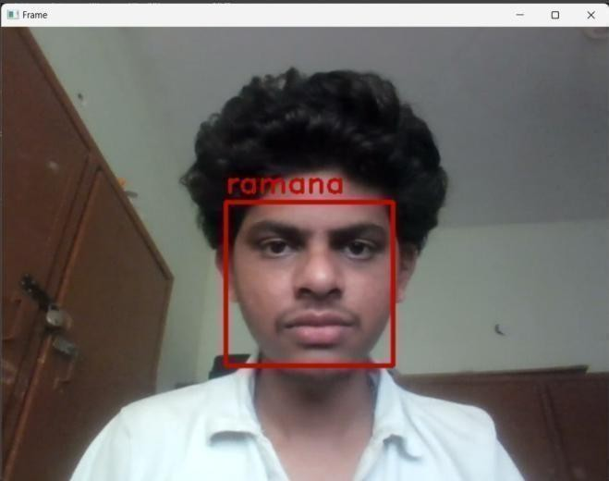

Figure 4: Single Face Detection

1. Face Recognition algorithms analyze each face, for example ResNet34 or HOG (Histogram of Oriented Gradients). These approaches process the image and produce different facial embeddings. The embeddings are when face data were compared in the database with pre- stored face data via similarity measures such as Euclidean distance If a match is present, the system continues marking out not for that person.
2. Once face identification identifies a person, Logs the attendance on the system. The system records the name of the person matched with, and the this, an Excel spreadsheet of filename is created, containing a timestamp date and date.

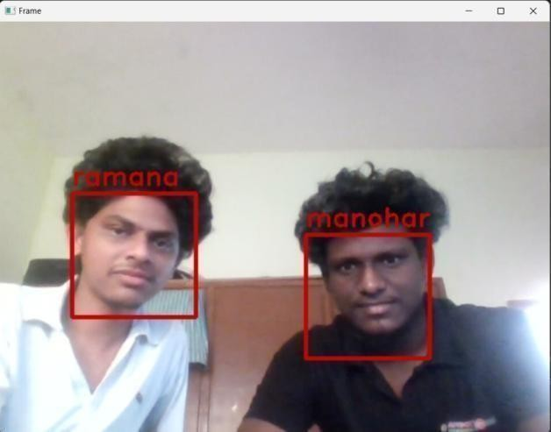

Figure 5: Multiple Face Detection

1. Face recognition analyzes every single face algorithms like ResNet34 & HOG (HOG: Histogram of Oriented Gradients). If a face match is recognized system marks attendance for that and so on. individual. Every successful match gets updated automatically so no manual intervention is required while marking attendance. If more than one personality is detected in the image, it stamps the attendance of all identified individuals at the appropriate time. If there are no the system records a timestamp as a “No Match” status, or it may be skipped, based on the configuration. All attendance records are saved in a single Excel file acting like a DB.
2. This file generally has columns for names and attendance timestamps, and possibly other information like the class name or the session. It makes it easier to track and export it for reporting or administrative purpose.

# 6. Conclusion

ResNet-34 for feature extraction—the system transforms input face images to the discriminative vectors of features that represent an individual's unique mouth characteristics. HIGH-DIMENSIONAL EMBEDDINGS These are then

measured by Euclidean distance and provide a good degree of face matching. A well-calibrated threshold guarantees the system can minimize false positives/negatives well, thereby improving overall reliability.

Real-time Processing of Live Video Streams Using the System imagem2 not only simplifies the process of attendance but also minimizes We expect that this might

lead to dishonest attendance practices. This the educational and organizational articulation, the efficiency is the main places where attendance records must be kept in real time and accurately are essential. Moreover, modularity and scalability to scale and enterprise of the system to be used in any settings, from small classrooms, big institutions.

# 7. Future Scope

The fate of a integrated face recognition and recognition participation framework has many open doors for development and upgrades both locally and broadly. The first most noticeable improvement is the connection of the system with smart devices that have IoT connectivity. Seamless and Automatic Access Control - By integrating facial recognition with IoT cameras and security systems, institutions and workplaces can achieve seamless and automatic access control. It can also be used with smart homes, where doors, lights and appliances can be programmed to respond to a person.

The system can be integrated with multi-factor authentication (MFA) for higher security environments. The system could, for instance, have a rule that face recognition will not be the only identification method used, and fingerprint scanning, voice-based recognition, or OTP-based authentication must also be enabled. It added another layer of security since this therefore made it harder for people to illegally access the content.

# 8. References

1. Hajar Filali Jamal, Riffi Adnane Mohamed Mahraz, Hamid Tairi, "Multiple Face Detection Based on Machine Learning," 978-1-5386-4396-9/18/$31.00, 2018 IEEE.
2. Ravi Kumar, S. Gupta, "Enhanced Face Recognition for Automated Attendance Using CNN," 2019 IEEE International Conference on Computer Vision and Pattern Recognition, 2019 IEEE.
3. Maria Lopez, Carlos Fernandez, "Face Embedding Techniques for Accurate Attendance Systems," Proceedings of the 2020 IEEE International Conference on Big Data, DOI: 10.1109/BigData50027.2020.00123, 2020 IEEE.
4. Anil Kumar, Sunita Patel, "Robust Face Detection and Recognition Using Transfer Learning," 2020 IEEE 5th International Conference on Advanced Computing and Communication Systems, 2020 IEEE.
5. Ling Wei, Zhenyu Zhang, "Optimizing Facial Recognition Accuracy in Crowded Environments," Journal of Real-Time Image Processing, Vol. 17, No. 3, 2021, DOI:10.1007/s11554-021-01023-8.
6. Amrita Singh, Rajesh Kumar, "Real-Time Attendance Monitoring with Facial Recognition Using Mobile Devices," 2022 IEEE International Symposium on Mobile Computing and Networking, 2022 IEEE.